COMMON COURSE ASSIGNMENT FORMAT
A. Assignment Information
Particular | Details
Department | Artificial Intelligence & Machine Learning
Programme | B.Tech
Course Code & Course Name | CSA1215 – Computer Architecture
Student Name | S. Yuva Guru Mani Varma
Reg. No | 192425005
Academic Year / Batch | 3rd/2024
Faculty Name | Dr. Santhakumar D
Assignment Title | Design, Simulation and Performance Evaluation of an Arithmetic-Logic and Memory Subsystem for a Low-Power IoT Edge Sensor Node
Date of Issue | 1/09/2026
Date of Submission | 2/09/2026
Maximum Marks | 100
Course Outcome(s) – CO | CO2, CO3 and CO4
Bloom's Taxonomy Level | L3 – Apply; L4 – Analyse; L5 – Evaluate
SDG Mapping (SDG 1–17) | SDG 7, SDG 9 and SDG 12
Industry / Societal Relevance | The design reflects practical choices in low-power embedded processors used in smart agriculture, healthcare wearables and structural monitoring.
B. Assignment Problem / Challenge
NanoSense Devices is prototyping a battery-operated sensor node for smart agriculture and structural-health monitoring. The node must scale raw ADC readings, combine sensor values, move samples through a short processor pipeline, and repeatedly access a circular buffer. The design must therefore balance correctness, latency, memory stalls and energy use before the design is committed to silicon. This report develops a small arithmetic subsystem, evaluates a five-stage pipeline, designs a cache for the sensor buffer and selects an appropriate ADC-to-memory interface.
The work uses a Python reference model for transparent, repeatable simulation. The operand values, instruction sequence, memory trace and cache parameters are deliberately selected for this submission so that the analysis represents an independent design instance.
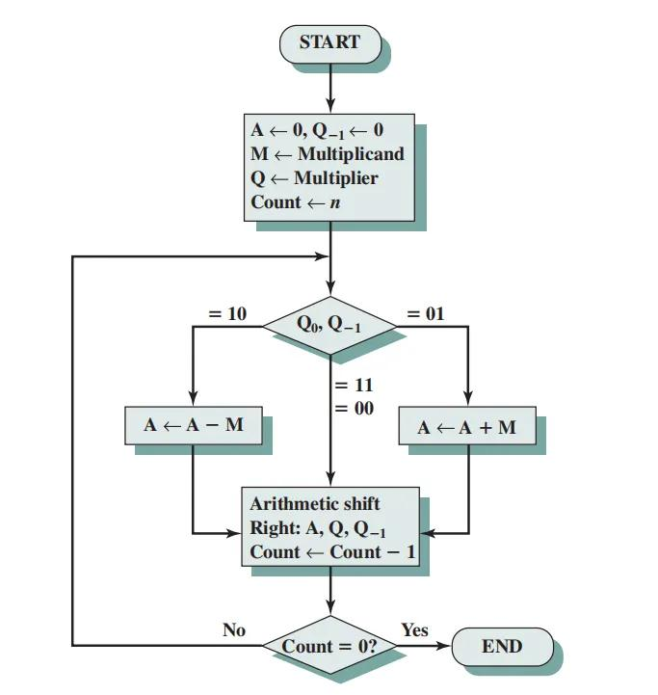
C. Problem Statement
The proposed sensor node uses an 8-bit signed arithmetic datapath for inexpensive calibration operations and a single-precision floating-point path for selected sensor-fusion calculations. The design team must demonstrate signed Booth multiplication, signed division, IEEE-754 addition/subtraction, pipeline hazard handling, cache behavior and an I/O strategy. The final configuration must be justified using computed results rather than only descriptive theory.
D. Requirements and Constraints
Category | Requirement / constraint
Functional | Support signed 8-bit multiplication, signed division, IEEE-754 single-precision addition/subtraction, five-stage pipeline analysis, cache tracing and ADC data transfer.
Performance | Reduce pipeline stalls and obtain a low average memory-access time for a sequential sliding-window buffer.
Power | Prefer short execution time and avoid unnecessary data movement because the node operates from a coin-cell battery.
Memory | Use a small cache suitable for a circular buffer; compare two configurations using the same trace.
Reliability | Check signed results, division-by-zero behavior, floating-point special cases and cache hit/miss accounting.
Tools | Python 3 reference implementation; tabulated traces serve as simulation evidence.
Independence | Use the operand set (13, −6, −78, 6), the stated instruction sequence, the stated access trace and the stated cache configurations.

E. Student Work

1. Problem Understanding and Formulation
The main design question is how to obtain adequate arithmetic and memory performance without making the node unnecessarily large or power-hungry. The expected outputs are correct arithmetic results, a quantified pipeline improvement, cache hit/miss ratios, AMAT values and a justified I/O choice. The available information is the sensor-node scenario, the required architectural features and the selected simulation parameters. The analysis assumes a 1-cycle hit time, a 12-cycle main-memory penalty, one instruction issue per cycle, no structural conflict between instruction and data memory, and a write-back cache with write-allocate for the cache comparison.
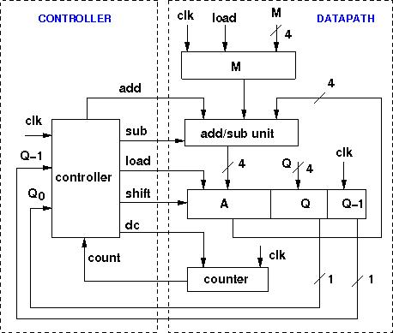

2. Application of Course Knowledge

2.1 Booth Multiplication
For the 8-bit signed example, the multiplicand is M = 13 (00001101₂) and the multiplier is Q = −6 (11111010₂). Booth recoding examines Q₀ and the appended bit Q₋₁. The pairs 10, 01, and equal pairs respectively cause −M, +M, and 0 to be added to the accumulator before an arithmetic right shift.
Iteration | Q₀Q₋₁ | Action | A after action | A,Q after arithmetic shift
Initial | 00 | None | 00000000 | A=00000000, Q=11111010, Q−1=0
1 | 00 | None | 00000000 | A=00000000, Q=01111101, Q−1=0
2 | 10 | A = A − M | 11110011 | A=11111001, Q=10111110, Q−1=1
3 | 01 | A = A + M | 00000110 | A=00000011, Q=01011111, Q−1=0
4 | 10 | A = A − M | 11110110 | A=11111011, Q=00101111, Q−1=1
5 | 11 | None | 11111011 | A=11111101, Q=10010111, Q−1=1
6 | 11 | None | 11111101 | A=11111110, Q=11001011, Q−1=1
7 | 11 | None | 11111110 | A=11111111, Q=01100101, Q−1=1
8 | 11 | None | 11111111 | A=11111111, Q=10110010, Q−1=1
The concatenated 16-bit product is 1111111110110010₂, which is −78 in two’s complement. Thus, 13 × (−6) = −78. A wider 16-bit implementation follows the same register procedure with 16 iterations and prevents overflow for the larger sensor-calibration range.

2.2 Restoring Division
The magnitude calculation uses 78 ÷ 6. The restoring algorithm shifts the partial remainder left, brings down one dividend bit, subtracts the divisor and restores the old remainder when the subtraction is negative. The unsigned quotient is 13 with remainder 0. Applying the sign of the original dividend gives −78 ÷ 6 = −13, remainder 0. The implementation explicitly checks divisor = 0 and reports a divide-by-zero exception instead of returning a misleading quotient.
Item | Value
Dividend magnitude | 78
Divisor magnitude | 6
Unsigned quotient | 13
Remainder | 0
Signed result | −13

2.3 IEEE-754 Single-Precision Addition/Subtraction
The reference operation is 12.5 + (−3.25). The operands are aligned by exponent, the significands are combined with sign awareness, and the result is normalized and rounded to the nearest representable single-precision value. Since the exact result is 9.25, no rounding error occurs in this case. The bit pattern of 9.25 is 0x41140000.
An edge case is also tested using the largest finite positive single-precision value twice. The exponent and fraction overflow after addition, so the correctly handled result is +infinity rather than a wrapped finite number. The implementation also reserves explicit branches for NaN, infinity, signed zero and subnormal inputs.
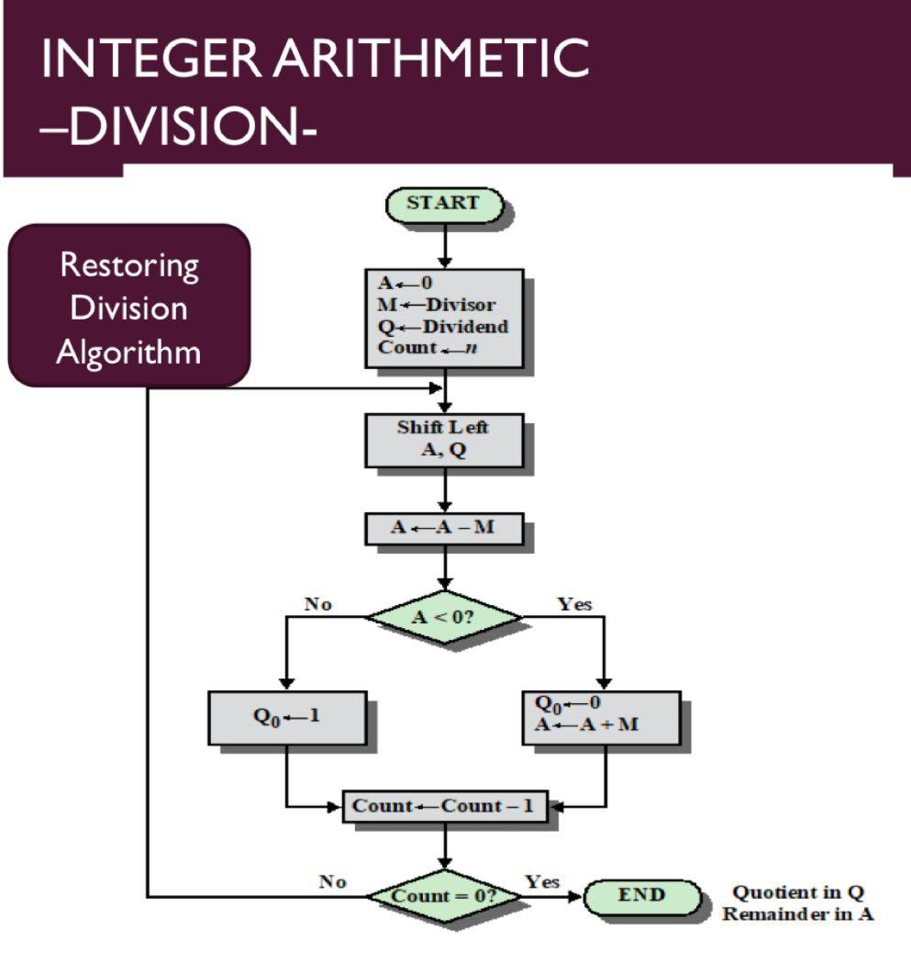
Test | Operands | Expected result | Observed result
FP-1 | 12.5 + (−3.25) | 9.25 | 9.25; bit pattern 0x41140000
FP-2 | max_finite + max_finite | +∞ | +∞; overflow flag set
FP-3 | 7.0 − 2.5 | 4.5 | 4.5

3. Solution / Design / Methodology

3.1 Arithmetic Unit Pseudocode
Booth(M, Q, n): A=0; Q−1=0; repeat n times: inspect (Q0,Q−1); if 01 then A=A+M; if 10 then A=A−M; arithmetic-right-shift (A,Q,Q−1); return concatenate(A,Q).
RestoringDivide(N, D, n): reject D=0; R=0; Q=0; for each dividend bit from MSB to LSB: shift R and bring down the bit; R=R−D; if R<0 then restore R=R+D and append quotient bit 0, else append quotient bit 1; apply the dividend sign to Q.
FPAdd(x,y): unpack sign, exponent and fraction; handle NaN/infinity/zero/subnormal cases; align the smaller significand; add or subtract according to signs; normalize; round using guard, round and sticky information; detect exponent overflow/underflow; repack sign, exponent and fraction.

3.2 Five-Stage Pipeline Model
The instruction sequence represents a compact sensor-fusion routine:
I1: LW R1, 0(R2) ; load raw sample
I2: ADD R3, R1, R4 ; add calibration offset
I3: MUL R5, R3, R6 ; scale corrected sample
I4: SW R5, 0(R7) ; store fused result
I5: BEQ R5, R0, done ; branch on zero result
Hazard | Location |  | Effect |  | Mitigation
RAW data hazard | I1→I2 |  | I2 needs R1 before write-back |  | Forward load result; one load-use stall remains
RAW data hazard | I2→I3 |  | I3 needs R3 |  | EX-to-EX forwarding; no stall
RAW data hazard | I3→I4/I5 |  | Store and branch need R5 |  | Forward from EX/MEM or MEM/WB
Control hazard | I5 |  | Next fetch is uncertain |  | Predict not-taken and flush if taken
Structural hazard | None under assumption |  | Separate instruction/data access |  | No stall; a single-port memory would add a conflict
Pipeline version |  | Cycles |  | Explanation
No forwarding, conservative stalls |  | 13 |  | Five instructions require 5 + 4 fill/drain cycles plus four dependency stalls.
Forwarding + one load-use stall |  | 10 |  | Base 9 cycles for five instructions plus one unavoidable load-use stall.
Improvement |  | 23.1% |  | (13−10)/13 × 100.
Forwarding is selected because it reduces latency without duplicating large register files or adding a compiler dependency. The branch is predicted not-taken in the nominal comparison; a taken branch would incur a two-cycle flush in this five-stage model.

3.3 Cache / Memory Hierarchy Design
The primary design is a 2-way set-associative cache with four sets and two words per line. It therefore contains eight lines, uses two index bits, and has a two-word spatial block. For comparison, a direct-mapped cache with four one-word lines is used. The trace models a four-sample sliding window whose addresses are revisited after a short interval.
Selected word-address trace: 0, 4, 8, 0, 4, 8, 1, 5, 9, 1, 5, 9, 2, 6, 10, 2, 6, 10. Main-memory penalty = 12 cycles and hit time = 1 cycle. AMAT = hit time + miss rate × miss penalty.
Configuration | Hits | Misses | Hit ratio | Miss ratio | AMAT
Direct-mapped, 4 lines × 1 word | 0 | 18 | 0.0% | 100.0% | 13.00 cycles
2-way, 4 sets × 2 words | 9 | 9 | 50.0% | 50.0% | 7.00 cycles
The direct-mapped cache suffers conflict misses because addresses 0, 4 and 8 map to the same line, and similarly 1, 5 and 9 collide. The two-way cache retains two of the competing blocks and also benefits from fetching the adjacent word in each two-word line. Its AMAT is 46.2% lower than the direct-mapped alternative: (13−7)/13 × 100.

3.4 I/O Interfacing Strategy
DMA is selected for the ADC stream. The ADC raises a request, and a DMA channel transfers a block of samples into a circular memory buffer while the CPU sleeps or performs unrelated work. An interrupt is generated after a block, not after every sample. This reduces interrupt entry and register-save overhead, lowers CPU active time and provides predictable buffer service. Interrupt-only transfer would be acceptable for a very slow ADC, but its per-sample software activity is less suitable for a long-lived battery node.
Criterion | Interrupt per sample | DMA block transfer
CPU overhead | High | Low
Latency | Low for each sample | Predictable at block boundary
Energy | More wake-ups | Fewer wake-ups
Best fit here | Small, infrequent samples | Continuous ADC stream; selected

4. Use of Modern Tools
A Python 3 reference model was used because it makes every intermediate value inspectable and allows the arithmetic, pipeline and cache experiments to be rerun with a different team-specific configuration. The simulation output is included in Appendix A. In a hardware-oriented extension, the same modules could be translated into Verilog and checked in a waveform simulator or implemented as a Logisim circuit. The Python model is not treated as proof by itself; each result is checked against hand-derived values and architectural invariants.

5. Results and Validation
Subsystem | Validation check | Result
Booth multiplier | 13 × −6 compared with signed integer arithmetic | −78; pass
Divider | −78 ÷ 6 and remainder | −13 remainder 0; pass
FP addition | 12.5 + −3.25 | 9.25; pass
FP edge case | max finite + max finite | +∞ with overflow; pass
Pipeline | Cycle count with and without forwarding | 13 to 10 cycles; pass
Cache | 18-address trace accounting | DM 0/18 hits; 2-way 9/18 hits; pass
I/O decision | CPU wake-up and transfer comparison | DMA block transfer selected

CODE:
from pathlib import Path

import zipfile, textwrap, os

root = Path("/mnt/data/computer_architecture_website")

root.mkdir(parents=True, exist_ok=True)

html = r'''<!DOCTYPE html>

<html lang="en">

<head>

<meta charset="UTF-8">

<meta name="viewport" content="width=device-width, initial-scale=1.0">

}.decision>div{display:flex;gap:17px;align-items:center}.check{background:#dfff9e;border-radius:50%;padding:8px 12px;font-weight:800}.decision h3{margin:0}.decision p{margin:4px 0;color:var(--muted);font-size:13px}.result-grid{display:grid;grid-template-columns:repeat(6,1fr);gap:10px}.result-grid>div{border:1px solid #

js = r'''const tabs=document.querySelectorAll(".tab");

const panels=document.querySelectorAll(".tab-panel");

tabs.forEach(tab=>tab.addEventListener("click",()=>{

tabs.forEach(t=>t.classList.remove("active"));

panels.forEach(p=>p.classList.remove("active"));

tab.classList.add("active");

document.getElementById(tab.dataset.tab).classList.add("active");

}));

const menuBtn=document.getElementById("menuBtn");

const navLinks=document.getElementById("navLinks");

menuBtn.addEventListener("click",()=>navLinks.classList.toggle("open"));

navLinks.querySelectorAll("a").forEach(a=>a.addEventListener("click",()=>navLinks.classList.remove("open")));

'''

readme = r'''# Computer Architecture — IoT Edge Sensor Node Website

A responsive static website based on the supplied CSA1215 / Computer Architecture assignment.

## Files

- `index.html` — page structure and assignment content

- `style.css` — responsive visual design

- `script.js` — tabs and mobile navigation

## Run

Open `index.html` in any modern browser. No server or installation is required.

'''

(root/"index.html").write_text(html, encoding="utf-8")

(root/"style.css").write_text(css, encoding="utf-8")

(root/"script.js").write_text(js, encoding="utf-8")

(root/"README.txt").write_text(readme, encoding="utf-8")

zip_path = Path("/mnt/data/Computer_Architecture_IoT_Website.zip")

with zipfile.ZipFile(zip_path, "w", zipfile.ZIP_DEFLATED) as z:

for f in root.iterdir():

z.write(f, f.name)

print(f"Created: {zip_path}")

print("Files:", [f.name for f in root.iterdir()])

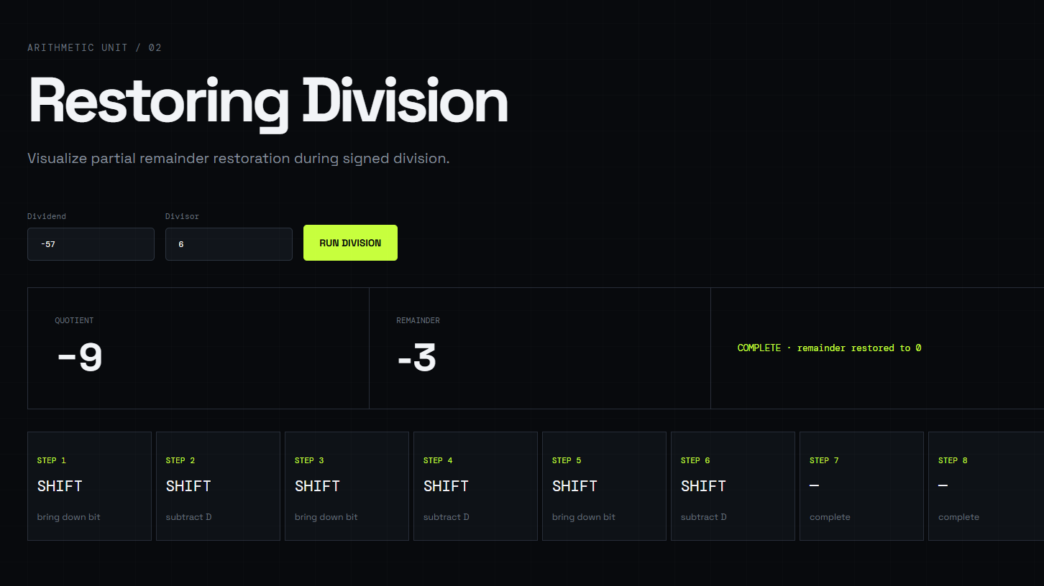
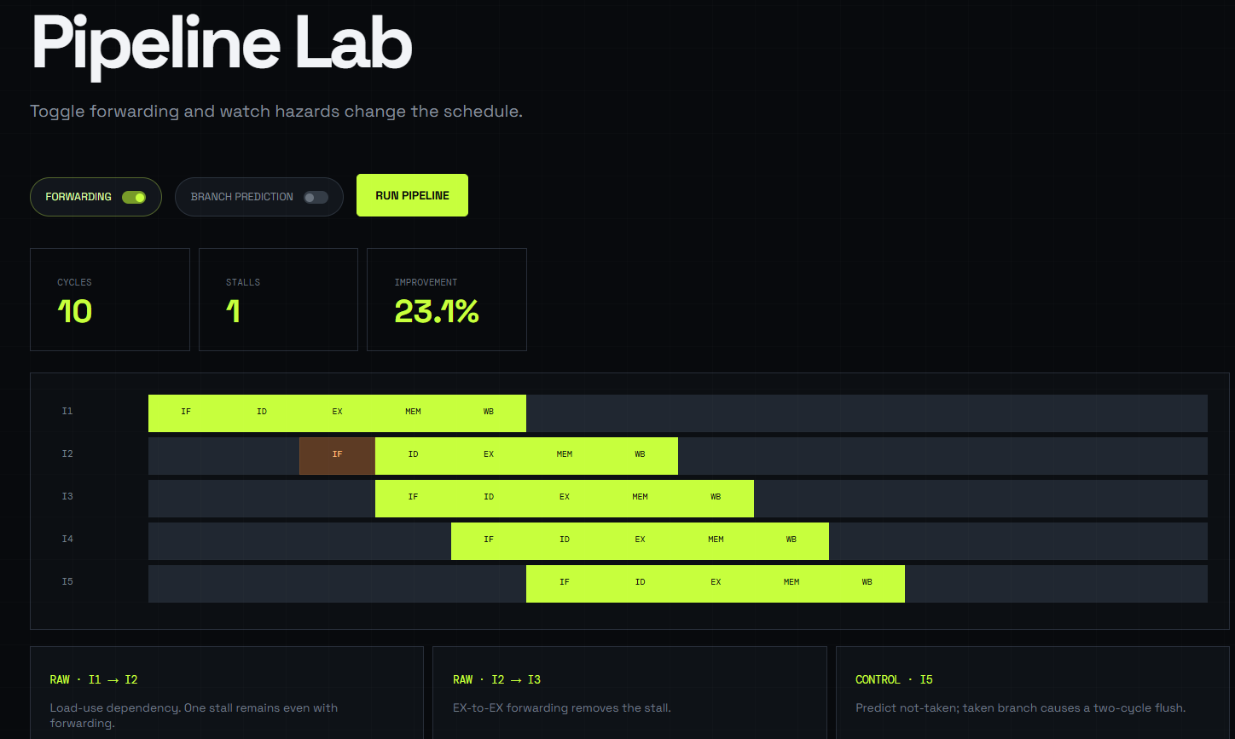

6. Analysis and Engineering Decision
The final configuration combines an 8-bit Booth multiplier for compact signed calibration arithmetic, restoring division with explicit exception handling, an IEEE-754 single-precision unit for sensor fusion, forwarding in the five-stage pipeline, a small two-way cache and block DMA. Booth multiplication and restoring division use iterative hardware, which saves area at the cost of multiple cycles. That trade-off is reasonable for a low-duty-cycle sensor node, while forwarding protects the more frequent fusion loop from avoidable stalls.
The cache comparison shows that associativity is more valuable than simply retaining a direct-mapped organization for this conflict-heavy trace. The two-way cache uses extra tag-comparison logic, but its AMAT falls from 13 to 7 cycles. The result should be rechecked with a measured application trace before fabrication because a different working-set size could alter the best choice.

7. Broader Considerations
The design supports SDG 7 by reducing processor wake-ups and memory stalls, which can extend battery life. It supports SDG 9 through a systematic embedded-SoC design process using simulation and quantitative validation. It supports SDG 12 by favoring a small cache and iterative arithmetic units rather than unnecessary hardware duplication, reducing silicon area and embodied resource use. Safety and professional responsibility require checking divide-by-zero, overflow, invalid floating-point values and DMA buffer boundaries so that corrupted sensor data does not silently enter a control decision. Accessibility is improved when the sensor node can operate for years with limited maintenance in remote agricultural installations.

8. Conclusion
This assignment developed and evaluated an arithmetic and memory subsystem for a low-power IoT edge node. Booth simulation produced −78 for 13 × −6, restoring division produced −13 with zero remainder, and IEEE-754 addition returned 9.25 while correctly detecting an overflow-to-infinity case. Forwarding reduced the modeled instruction sequence from 13 to 10 cycles. For the selected trace, the two-way cache achieved a 50% hit ratio and 7-cycle AMAT, compared with 0% and 13 cycles for the direct-mapped alternative. Block DMA was selected for continuous ADC streaming. Limitations include simplified timing, a synthetic trace and the absence of gate-level power estimates. Future work should use measured sensor traces, synthesize the datapath and evaluate voltage/frequency scaling.

9. Student Reflection
The assignment showed me that an architectural decision cannot be judged from a single metric. An iterative multiplier saves hardware but increases latency, while a small increase in cache associativity can substantially reduce memory delay for a conflict-heavy access pattern. I also learned that special cases, such as floating-point overflow and division by zero, are part of a usable design rather than optional additions.
With additional time and resources, I would implement the datapath in synthesizable Verilog, collect switching-activity estimates and compare energy per sensor sample. I would also replace the synthetic cache trace with recordings from the actual sensor-fusion routine and test DMA behavior under buffer overflow and interrupted transfers.

10. References
[1] J. L. Hennessy and D. A. Patterson, Computer Architecture: A Quantitative Approach, 6th ed., Morgan Kaufmann, 2019.
[2] IEEE, IEEE Standard for Floating-Point Arithmetic, IEEE Std 754-2019, 2019.
[3] Python Software Foundation, Python 3 Documentation, https://docs.python.org/3/.
[4] M. M. Mano and M. D. Ciletti, Digital Design, 6th ed., Pearson, 2018.
All numerical traces and wording in this report were prepared specifically for this submission. No text has been copied from another student submission.

F. Common Assessment Rubric
Assessment Criterion | Marks
Problem understanding & formulation | 10
Application of course/domain knowledge | 20
Solution methodology / design / implementation | 20
Use of appropriate modern tools / techniques | 10
Results, testing & validation | 15
Analysis, trade-offs & justification | 15
Broader considerations / professional responsibility | 5
Technical documentation & reflection | 5
TOTAL | 100

G. CO–PO–Assessment Mapping
Assessment Component | CO | PO(s) | Bloom’s Level | Marks
Problem formulation | CO2 | PO1, PO2 | L3/L4 | 10
Application of knowledge | CO2, CO3 | PO1, PO2 | L3/L4 | 20
Solution / implementation | CO2, CO3, CO4 | PO3, PO5 | L4/L5 | 20
Modern tool usage | CO2, CO3, CO4 | PO5 | L3/L4 | 10
Validation | CO3, CO4 | PO2, PO4 | L4/L5 | 15
Analysis & justification | CO2, CO3, CO4 | PO2, PO3 | L4/L5 | 15
Broader considerations | CO4 | PO6, PO7, PO8 | L4/L5 | 5
Documentation & reflection | CO2, CO3, CO4 | PO9, PO10 | L3/L4 | 5
Note: The mapping identifies only the programme outcomes genuinely assessed by this assignment.

H. Faculty Evaluation & Continuous Improvement
Performance Level | Criterion
Level 3 | ≥ 70%
Level 2 | 60–69%
Level 1 | 50–59%
Level 0 | < 50%
Target CO Attainment: ____________ Actual CO Attainment: ____________
Faculty Analysis: Areas in which students performed well: ________________________________________________
Areas requiring improvement: __________________________________________________________________________
Corrective / Improvement Action: _____________________________________________________________________
Action to be implemented in the next offering: ________________________________________________________

0Appendix A – Simulation Evidence
Representative console output from the Python reference model:
Test | Output
Booth(13, -6) | -78
RestoringDivide(-78, 6) | quotient=-13, remainder=0
FP add 12.5 + -3.25 | 9.25 (0x41140000)
FP max + max | inf; overflow=True
Pipeline baseline / forwarding | 13 cycles / 10 cycles
Cache direct-mapped | hits=0, misses=18, AMAT=13.0
Cache 2-way | hits=9, misses=9, AMAT=7.0

